Calibration Program Method Guideline

Prerequisites
Before you begin, ensure the following are prepared and ready:
- A circle grid calibration board (BDB-6) securely mounted on the cobot TCP.
- A working camera connected to the system and positioned to view the TCP area.
- An ARC Cobot connected and controllable via network.
- The Python environment and all required dependencies installed.

Step-by-Step Guide:
This section explains how to configure and run the collect_calibration_data.py script to capture images for calibration purposes.

Collecting Calibration Data
This guide explains how to configure and run the collect_calibration_data.py script to capture images for camera calibration.

Step 1: Open the Script
Locate and open the file: collect_calibration_data.py

Step 2: Update Configuration Settings
Inside the script, modify the following parameters:
- File Name for Saved Images
Set the filename or folder where captured images will be stored.
- Camera IP Address
Update the IP to match your connected camera device.
- Robot and PC IP Address
Set the pc and robot’s IP address for motion control.
Examples:
- File name : mechmind_logMleft_25jun
- Camera IP address : 192.168.100.205
- Robot IP address : 192.168.100.210
- PC IP address : 192.168.100.200
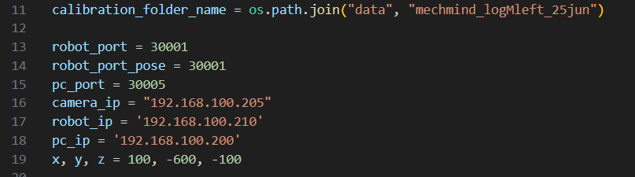

Step 3: Define Starting Pose
Physically move the robot so that:
- The calibration board is centered in the camera’s field of view.
- The Z-axis is perpendicular (normal) to the board.
Update the starting pose (XYZ and orientation) in the script:
This point will be used as the initial pose from which automated path movement begins.
Example :
Robot starting position : 100, -600, -100

Step 4: Run the Script
Once all settings are configured, run the script

Step 5: Verify Captured Images
The script will automatically capture and save images as the robot moves.
Check the saved files in the folder defined earlier (e.g., mechmind_logMleft_25jun) to ensure:
- All circles on the calibration target are clearly visible.
- The depth map of the circle grid is present and correctly rendered.

Step 6: Adjust as Needed
The image capture path is generated automatically.
If the board moves out of view or circles are not properly visible:
- Press the E-stop to halt the robot immediately.
- Adjust the robot’s starting position or orientation.
- Update the corresponding starting pose in the script.

Calibration grid selecting
This guide explains how to use calibration_grid_select_blob.py to label the calibration circles in the captured images for camera calibration.

Step 1: Open the Script
Locate and open the file: calibration_grid_select_blob.py

Step 2: Update the Image Folder Path
In the script, modify the path to point to the folder containing the saved calibration images.
Example :
Image folder : mechmind_logMright_25jun

Step 3: Run the Script
Once all settings are configured, run the script

Step 4: Select Calibration Circles
For each image that appears:
- The script will automatically detect and highlight all detected circles.
- To select the calibration grid:
- Click and drag with the left mouse button to draw a rectangle around the grid area.
- Ensure that only the calibration circles are included in the region.
- check the sequence numbers — they should start from the top-left circle and follow a row-wise order (left to right, then top to bottom).
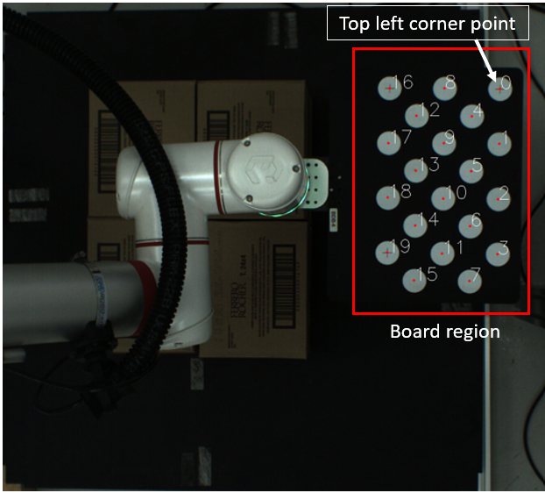

⚠️ Important:
If the region contains too few or extra circles, the script will prevent you from proceeding to the next step. In that case, reselect the region correctly.

Step 5: Select Top-Left Corner Circle
After selecting a valid region:
- Click on the top-left circle of the calibration board as shown in the previous image
- The top-left circle refers to the one located on the side with three circles and is the farthest from the TCP.
- This defines the orientation of the grid.
If you selected the wrong point:
- Right-click to restart the labeling for that image.

Step 6: Proceed or Skip
Once the region and corner are correctly selected:
- Press the spacebar to proceed to the next image.
If an image is incomplete (e.g., not all circles are visible):
- You may skip the image by pressing the spacebar without labeling.

Calibration grid selecting

Step 1: Open the Script
Locate and open the file: run_computation_scripts

Step 2: Update the Image Folder Path
In the script, modify the path to point to the folder containing the saved calibration images.
Example :
Image folder : mechmind_logMright_25jun
Copy and paste a camera.npz file based on the type of camera used from manufacturer_camera_parameters into the data file and rename it as camera_parameters.npz

Step 3: Run the Script
Once all settings are configured, run the script
After execution, three files will be generated in the output folder:
- optimized.npz
- board_alignment.npz
- extrinsic.npz
Take the optimized.npz file, rename it appropriately, and save it into the camera_parameters folder. This completes the calibration process.

